Week 7 – Hardware Development Update

Document Version Number: 5.1

Date: April 10, 2015

Author: Yu Chen Xu

Hardware Version: 5.1

Goal: To explain the updated version of physical model.

Contents

Back wheel modification 2

# Back wheel modification

During the 1st round of the competition, the robot is affected by the uneven level at the intersection of 4 tiles. It deviates a little bit. In fact, the back base support gets stuck for a moment at the intersection, causing the odometer to be inexact.

To fix this problem, the mechanical team replaced the base structure by round wheels, which make the robot easier to travel on uneven surfaces.

Before

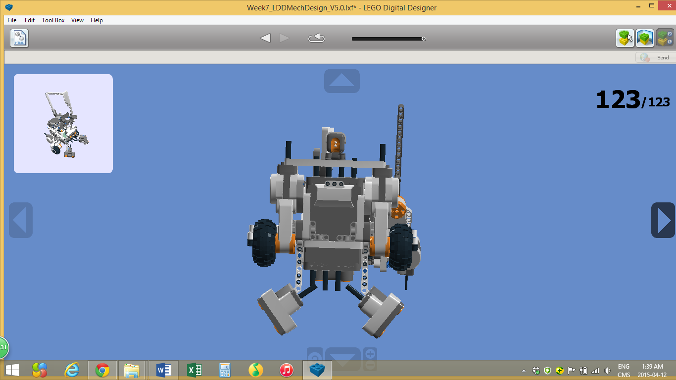

After

